1) Shape A is first reflected in the y-axis and then translated by the vector $\left({-2 \atop -6}\right)$to give Shape B.
Draw the transformations on the grid.

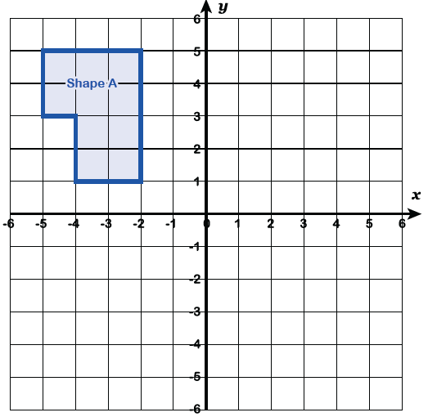

2) Triangle C is rotated 180° from the point (-1, 2) and is then reflected in the line y = x to give Triangle D.
Draw the transformations on the grid.
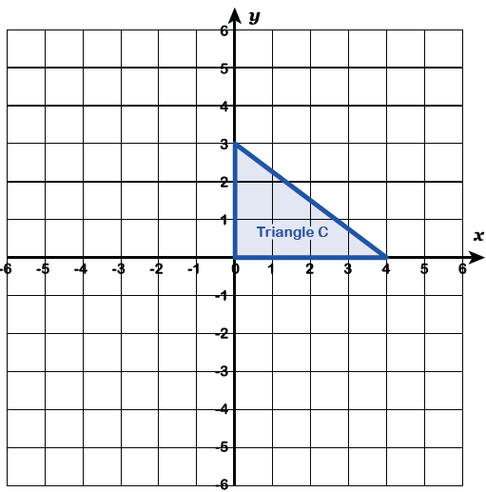

3) Shape E is first enlarged by a scale factor of -2
from the centre of enlargement (2,-3) and secondly
translated by the vector $\left({-4 \atop 3}\right)$ to give Shape F.
Draw the transformations on the grid.
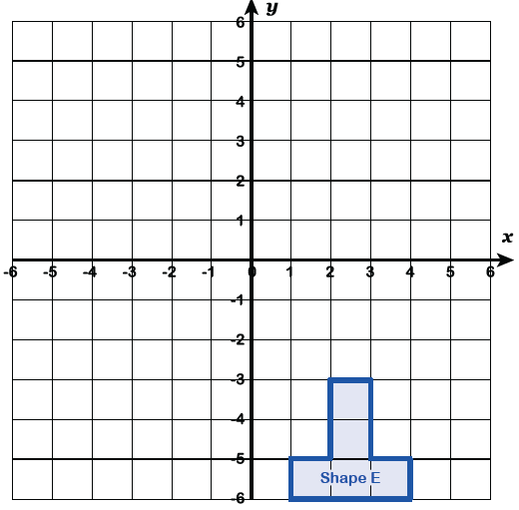

4) Shape G is rotated 90° clockwise about the origin and is then reflected in the line x = -3 to give Shape H.
Draw the transformations on the grid.
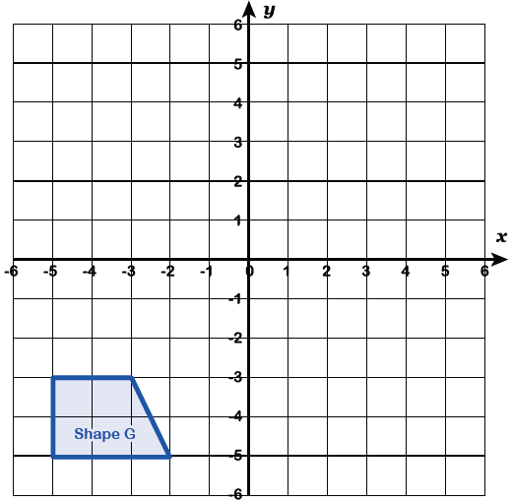
5) Triangle I is enlarged by a scale factor of ½, centre of enlargement (0, -1) and is then reflected in the line y = -x to give Triangle J.
Draw the transformations on the grid.
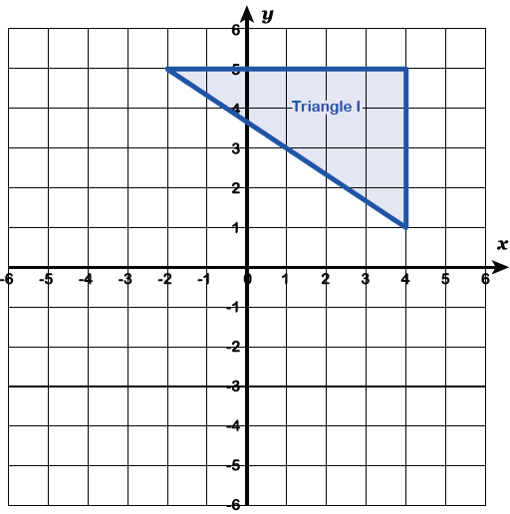
6) Shape K is first translated by the vector $\left({0 \atop -4}\right)$and is secondly rotated by 90° anti-clockwise about the point (-1, 0) to give Shape L.
Draw the transformations on the grid.
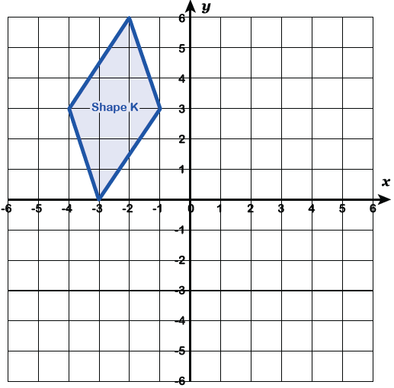

7) Triangle R is reflected in the y axis to give triangle S.
Triangle S is reflected in the line y = 1 to give triangle T.

Describe the single transformation that maps triangle R to triangle T.
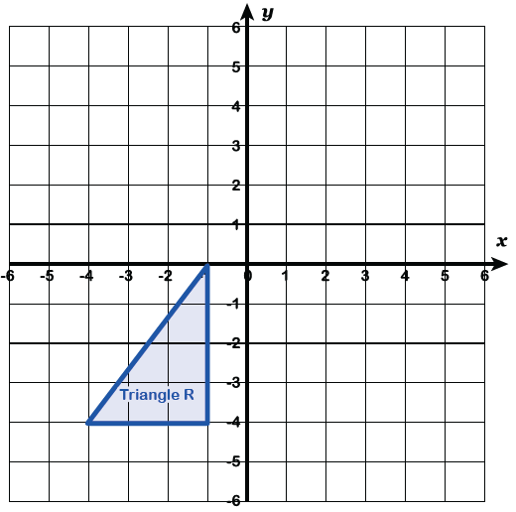
8) Triangle U is rotated 90° anti-clockwise about the point (0,3) to give triangle V. Triangle V is translated by the vector $\left({3 \atop -3}\right)$ to give triangle W.
Describe the single transformation that maps triangle U to triangle W.
