1) Find the missing length by constructing an accurate drawing of the triangles.
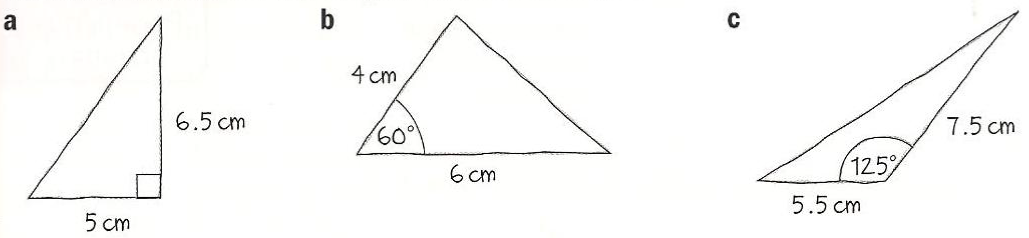
2) Find the missing two lengths by constructing an accurate drawing of the triangles.
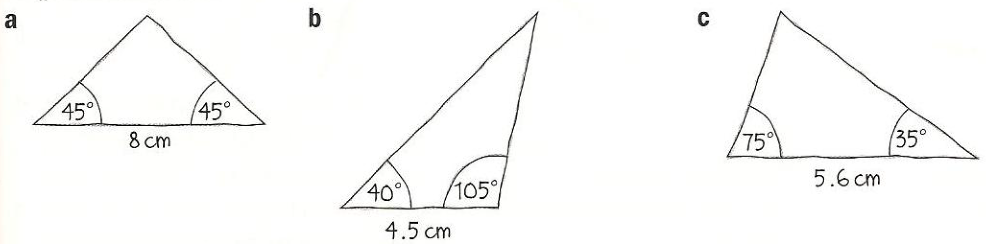
3) Find the marked angle by constructing an accurate drawing of the triangles.
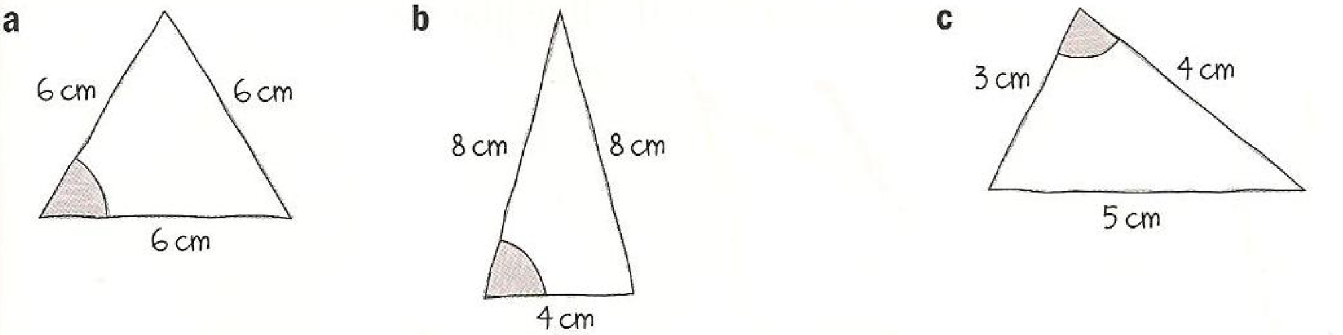
4) Find the marked angle by constructing an accurate drawing of the triangles.
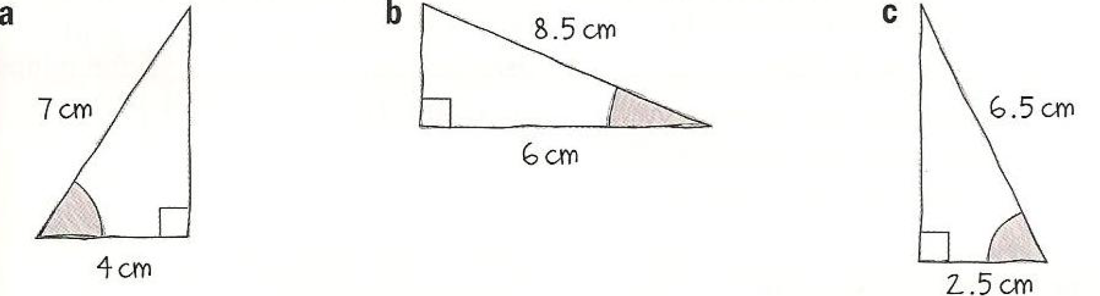
5) Why is it impossible to draw this triangle? Hint: Try constructing the triangle.
. 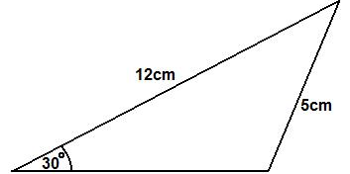
1) Find the missing length by constructing an accurate drawing of the triangles.
2) Find the missing two lengths by constructing an accurate drawing of the triangles.
3) Find the marked angle by constructing an accurate drawing of the triangles.
4) Find the marked angle by constructing an accurate drawing of the triangles.
5) Why is it impossible to draw this triangle? Hint: Try constructing the triangle.
.

