Find the volume of each prims. (Give you answer in terms of pi)
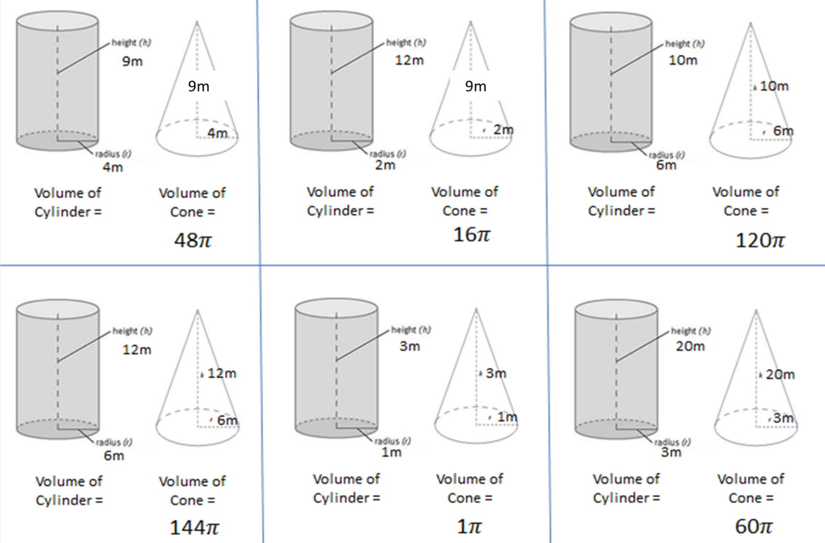
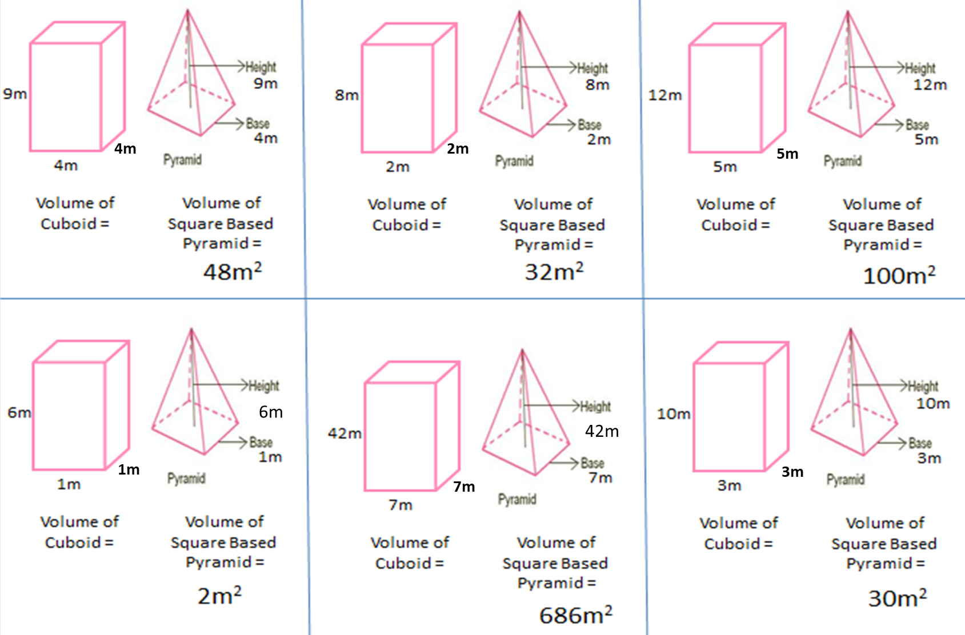
24m
24m
What is the connection between the volume of a prism and a pyramid?
Find the volume of each prims. (Give you answer in terms of pi)
24m
What is the connection between the volume of a prism and a pyramid?

