The Gym Problem
A local gym has three payment options.

Option A: £6 a session.
Option B: Pay a one off fee of £100 and then pay £4 per sessions.
Option C: £500 for a life membership and unlimited use of the gym.

Investigate which option is best and when.

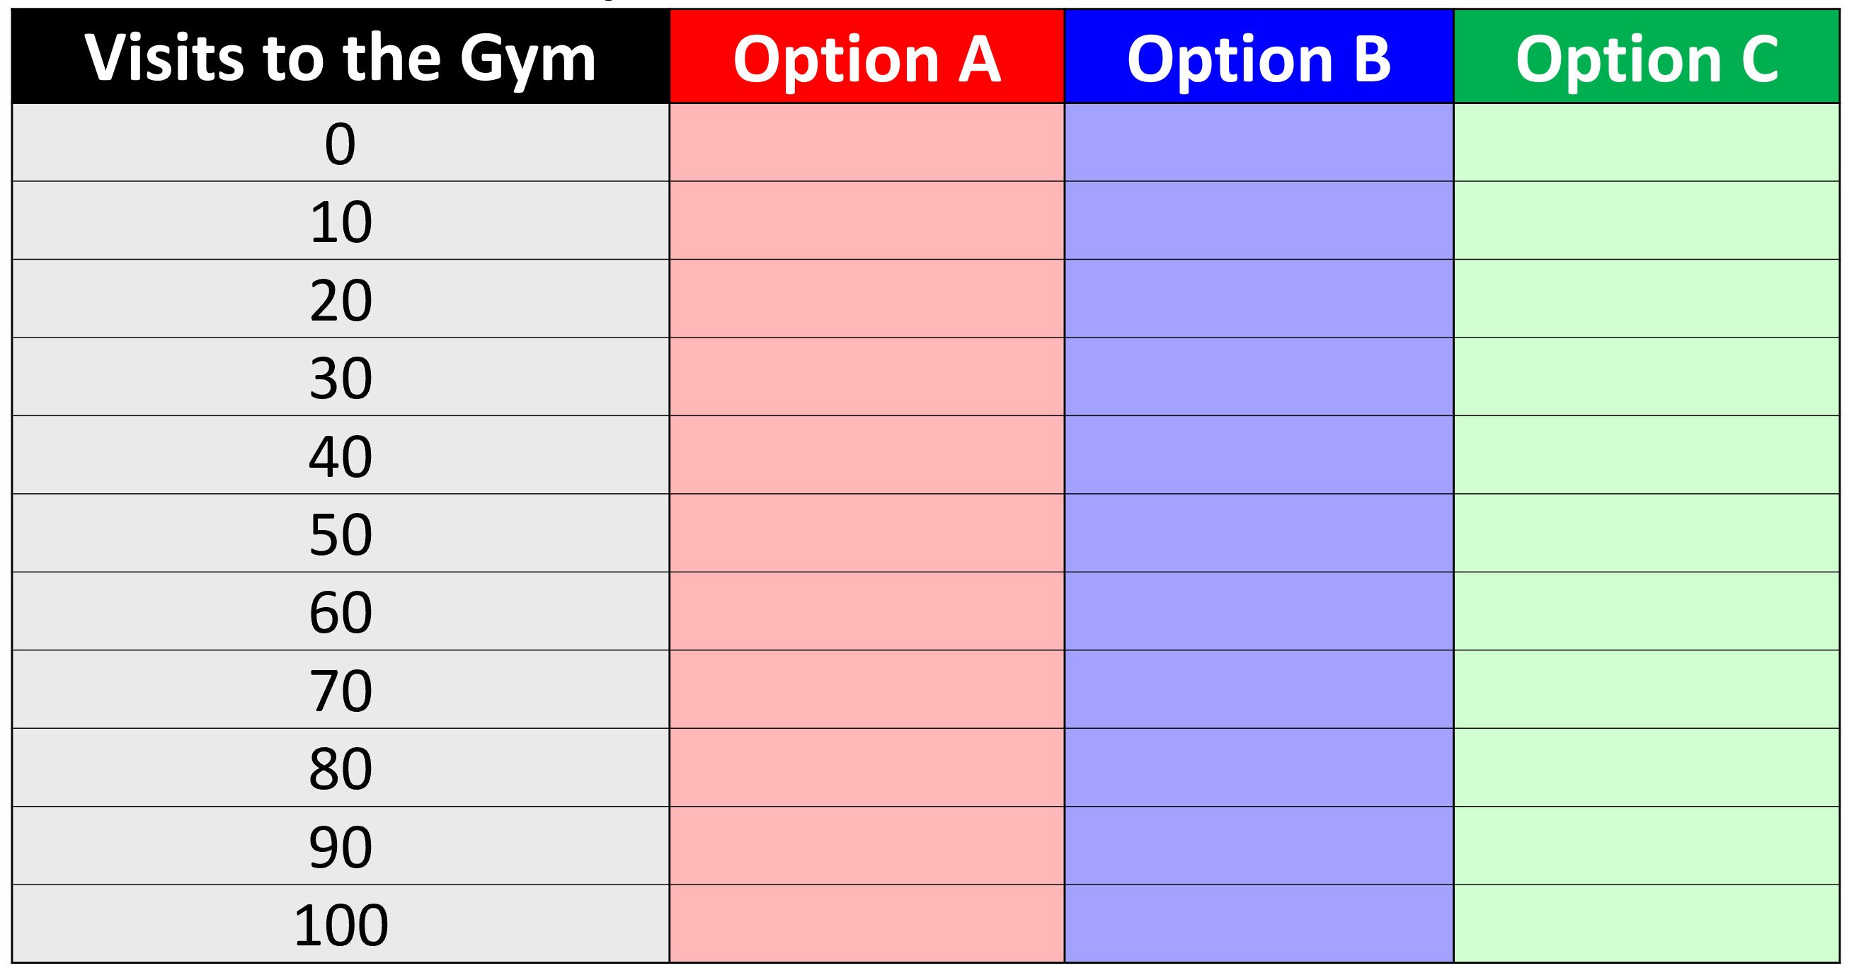

Write an equation for each option.

Option A:

Option B:

Option C:

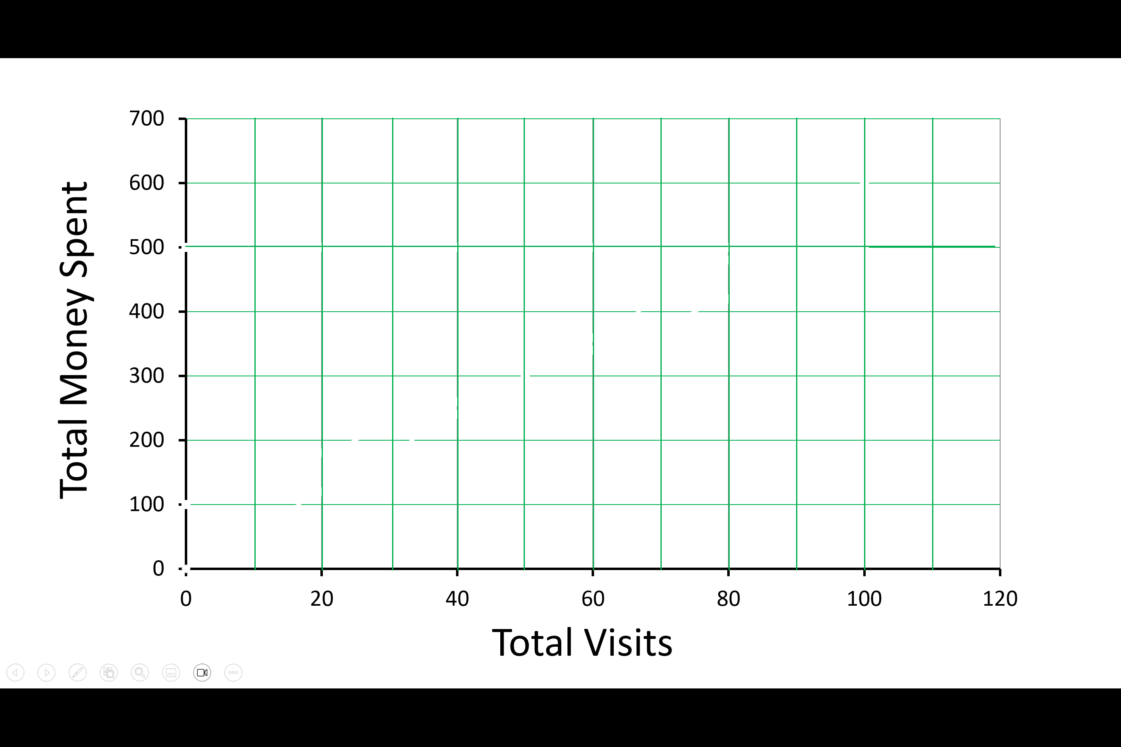
Which gym is the best and when?

