100 Metre Dash – Distance Time Graphs


There was a race yesterday, but it was slightly odd. Not all the runners started at the same time or the same place. It is your job to work out the missing information:

Ashleigh starts running on the starting pistol. She runs the 100 meters in 12 seconds. How fast was Ashleigh?

Bill starts running from the 25-metre mark. He reaches the finish line in 15 seconds. How fast was Bill?

Curtis starts running two seconds after the starting pistol. He crosses the finish line at the same time as A. How fast was Curtis?

Darren runs the full 100 meters at 11 meters per second. He started running at the sound of the starting pistol. How long did it take Darren?

Elliot started running at the starting pistol at 8 meters per second, but gave up after 7 seconds. How far did Elliot run?

Which runner was the fastest?

Which runner won the race?
Graph the different sprinters from the race.

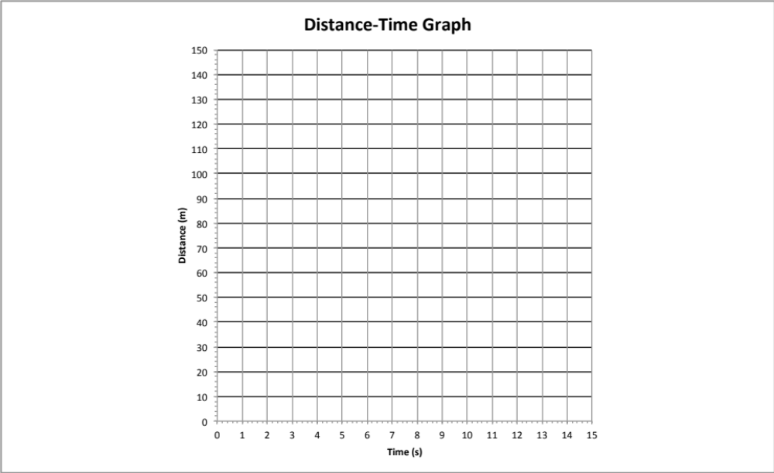

Work out the gradient of each line.

What does the gradient represent?

