Circumference of a Circle
1) Find the circumference of these circles. Give your answer in terms of pi.
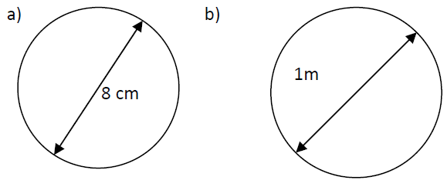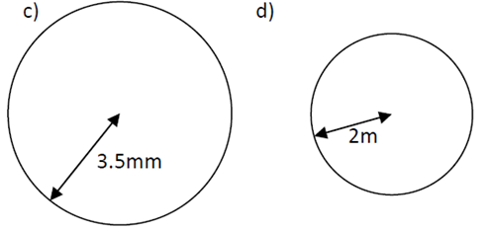

2) Find the circumference of these circles. Give you are answers to 1 decimal place.
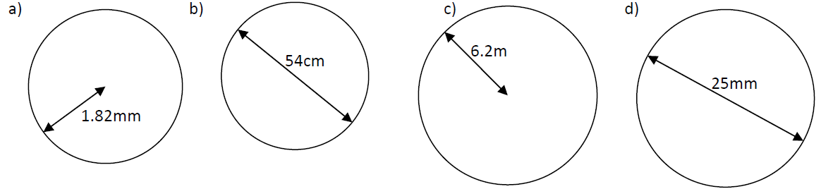

3) Find the perimeter of each shape. Give your answers to 1 decimal place.
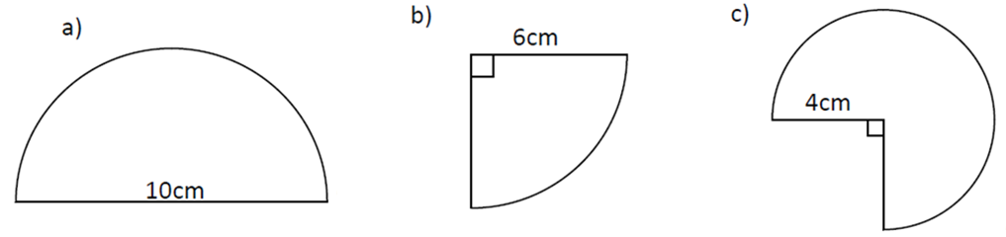

4) Find the radius of each circle. Give your answers to 1 decimal place.
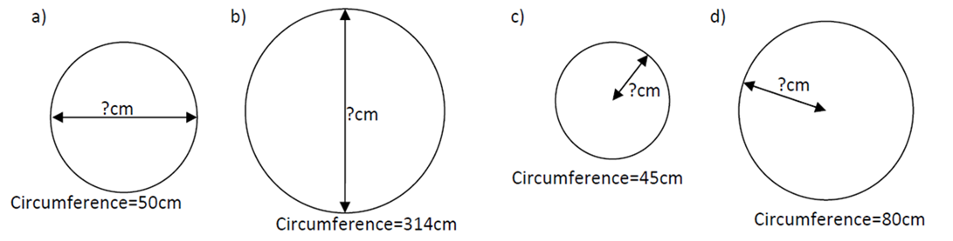
5) Find the perimeter of the shapes. Give you answers to 1 decimal place.
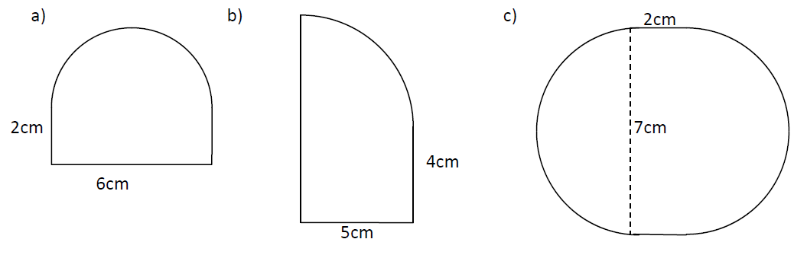
6) A bicycle has a wheel of radius 30cm.
a) Find the circumference of the wheel
b) How far does the bicycle go in 100 turns of the wheel?
Give your answers in metres.

7) Two circles of diameter 12cm and 8cm are cut and the then joined to make one large circle. Find the diameter of this larger circle.

8) A giant paper clip is place alongside a cm ruler. The curved ends are semicircles. Calculate the length of the wire used to make the paper clip.
