Find the volume of the cuboids
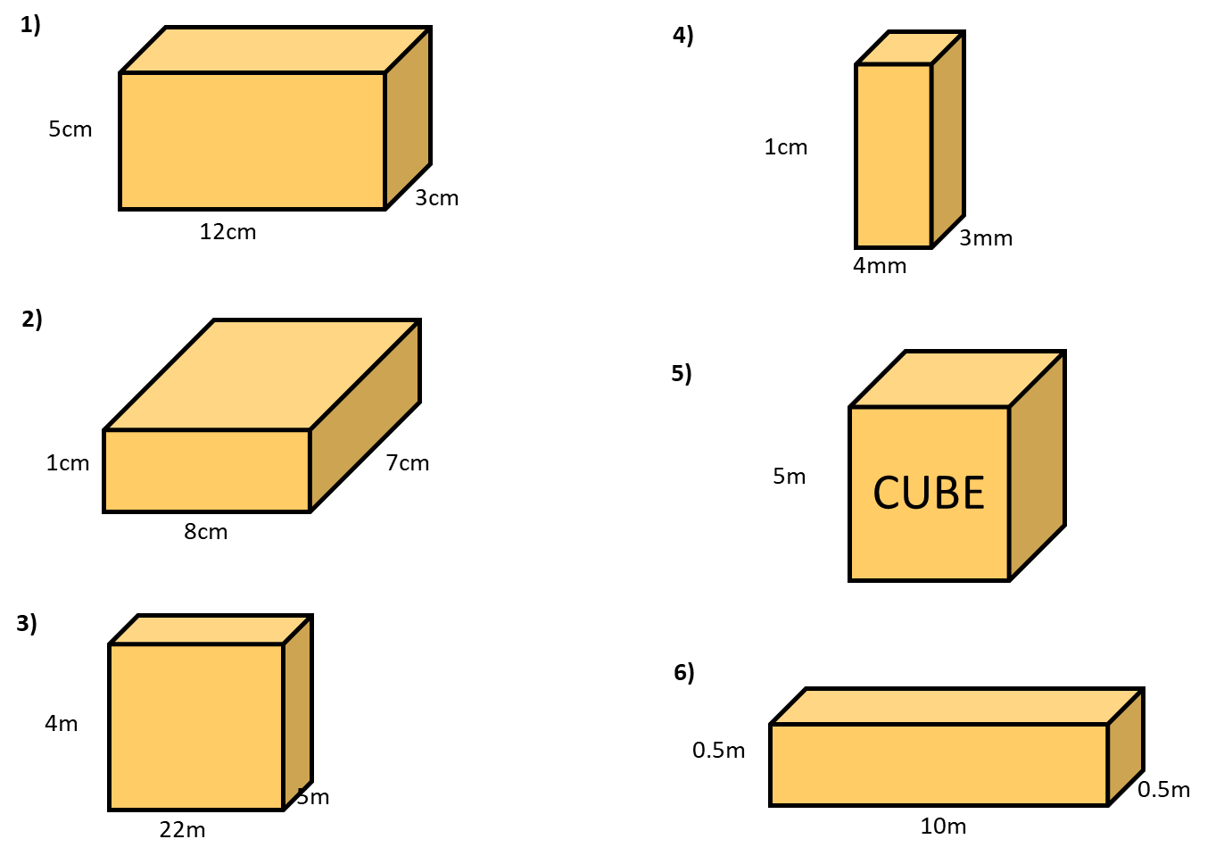
Find the missing sides.
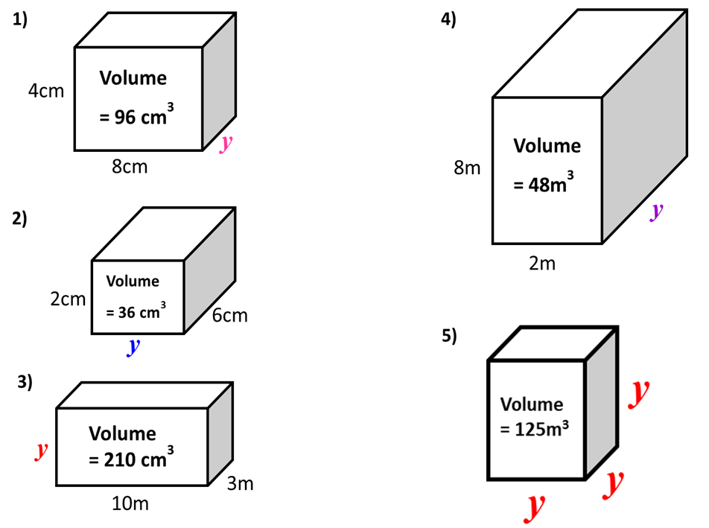
Complete the table.
 | Length | Width | Height | Volume
 | 2m | 7m | 3m |  | m³
 | 8cm | 5cm | 2cm |  | cm³
 | 7km | 7km | 10km |  | km³
 |  | 3m | 5m | 75 | m³
 | 8m |  | 10m | 800 | m³
 | 3cm | 3cm |  | 27 | cm³
cube |  |  |  | 8 | m³
 | 2m | 3cm | 2cm |  | cm³

Find the volume of the shapes.
