Harder Sequences and Diagrams
1)
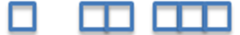
a) Find the nth term for the number of squares in each term.
b) Find the how many squares would be in term 100.
c) Will any pattern have 70 squares (give your reason)?

2)
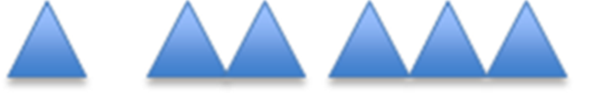
a) Find the nth term for the number of sides in each term.
b) Find the how many sides would be in term 70.
c) Will any pattern have 65 sides (give your reason)?

3)


a) If the length of each side is 2cm, find the perimeter of each term.
b) Find the nth term for the perimeter of each term.
c) What is the perimeter of pattern 50?
d) Will any pattern have a perimeter of 100cm (give your reason)?

4)

a) If the length of each side is 1cm, find the perimeter of each term.
b) Find the nth term for the perimeter of each term.
c) What is the perimeter of pattern 40?
d) Will any pattern have a perimeter of 120cm (give your reason)?

5)
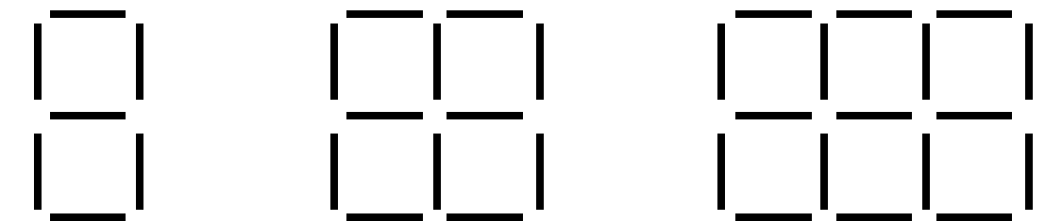
a) Write a formula for how many lines in each pattern
b) How many lines would be in pattern 50?
c) There 80 lines. What is the biggest completed pattern could you make?

6)
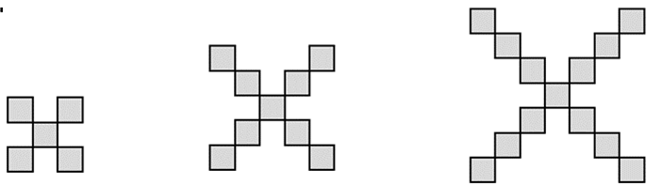
a) Write a formula for how many squares in each pattern.
b) How many squares would be in pattern 60?
c) There 100 squares. What is the biggest completed pattern could you make?

7)
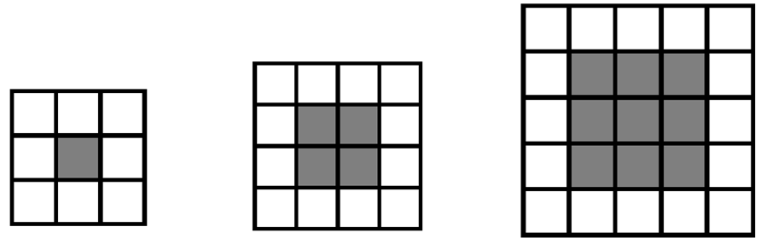
a) How many white tiles will there be in pattern number 10?
b) How many grey tiles will there be in pattern 8?
c) Miles has 49 grey tiles and 32 white tiles.
What is the biggest pattern that can be made?
d) Emma has 90 grey tiles and 42 white tiles.
She says she can make pattern number 10. She is incorrect, explain why.
e) How many more grey tiles will Emma need to make pattern number 10.

