For each triangle find the missing length. (Give answers to 1dp).
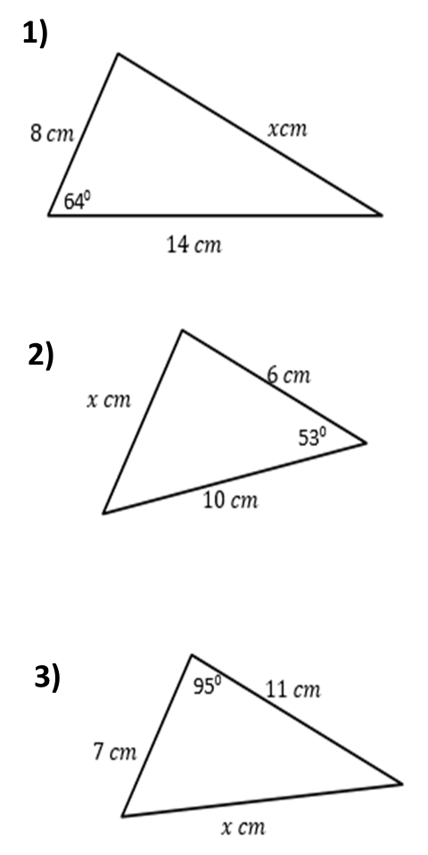
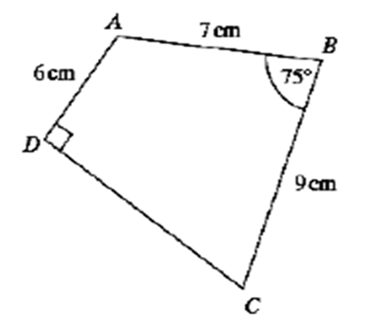
4) Calculate the perimeter of ABCD

For each triangle find the missing length. (Give answers to 1dp).
4) Calculate the perimeter of ABCD

