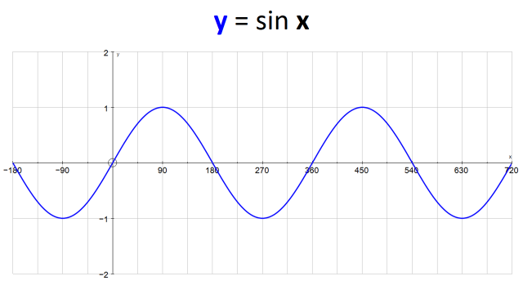
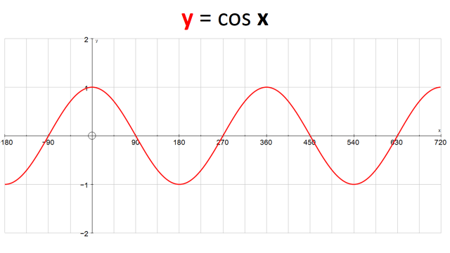
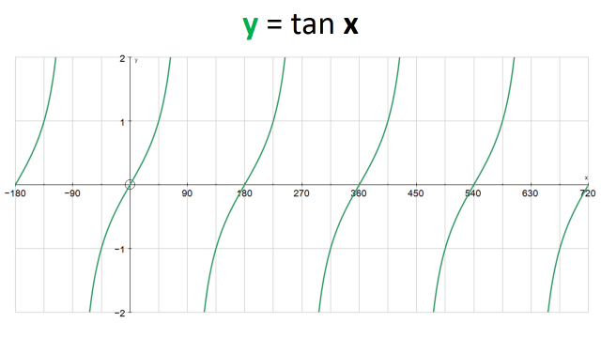
Sine Wave: y = sin x
How long is one cycle?
What is the maximum and minimum y values of the graph?
What are the co-ordinates when the graph intercepts the x axis (from -180 to 720)?
When will the graph intercept the x axis again (after 720)?
What is the co-ordinate when the graph intercepts the y axis?
When sin x = 1, what are the values of x over the interval -180 ≤ x ≤ 720?
When sin x = -1, what are the values of x over the interval -180 ≤ x ≤ 720?

Cosine Wave: y = cos x
How long is one cycle?
What is the maximum and minimum y values of the graph?
What are the co-ordinates when the graph intercepts the x axis (from -180 to 720)?
When will the graph intercept the x axis again (after 720)?
What is the co-ordinate when the graph intercepts the y axis?
When cos x = 1, what are the values of x over the interval -180 ≤ x ≤ 720?
When cos x = -1, what are the values of x over the interval -180 ≤ x ≤ 720?

Tangent Wave: y = tan x
How long is one cycle?
What is the maximum and minimum y values of the graph?
What are the co-ordinates when the graph intercepts the x axis (from -180 to 720)?
What is the co-ordinate when the graph intercepts the y axis?
When will the graph intercept the x axis again (after 720)?
When tan x = 1, what are the values of x over the interval -180 ≤ x ≤ 720?
When tan x = -1, what are the values of x over the interval -180 ≤ x ≤ 720?

