1) Find the perimeter of these rectangles. 2) Find the area of these rectangles.
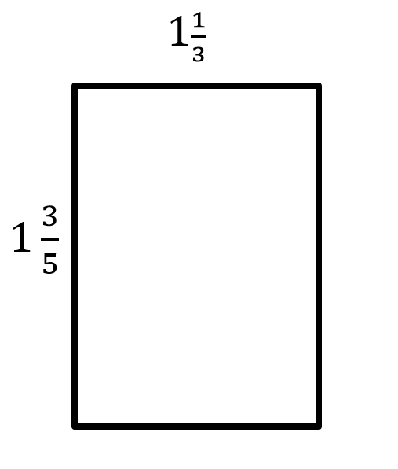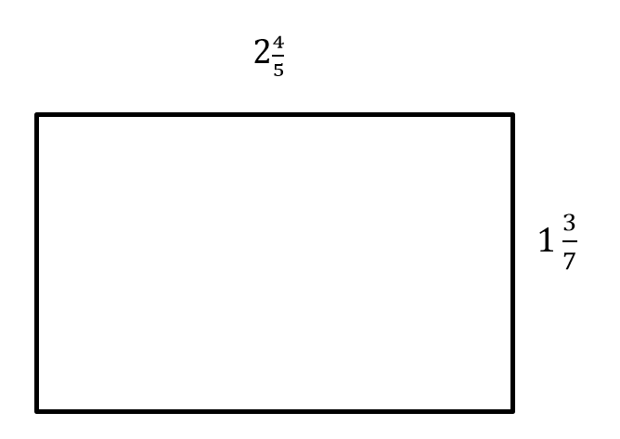

- Find the missing side of these rectangles. 4) Find the missing side of these rectangles.
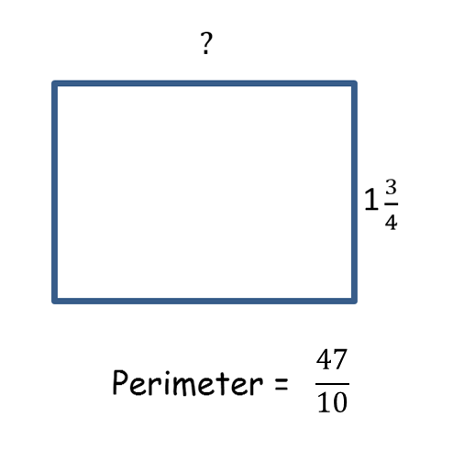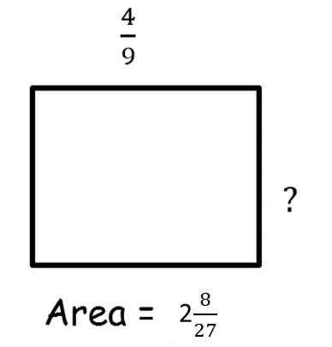

5) Find the area of these triangles.
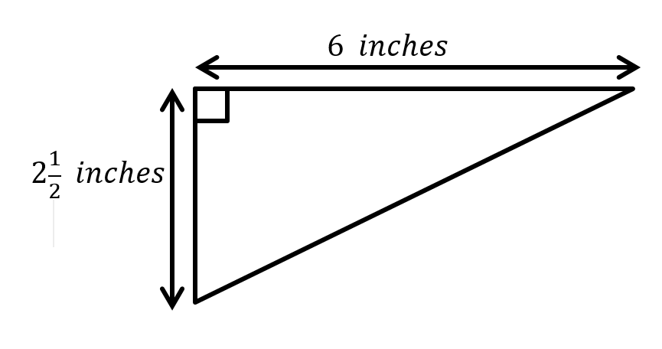

1) Find the perimeter of these rectangles. 2) Find the area of these rectangles.

- Find the missing side of these rectangles. 4) Find the missing side of these rectangles.

5) Find the area of these triangles.

