Task 1: Non-Calculator 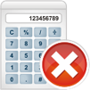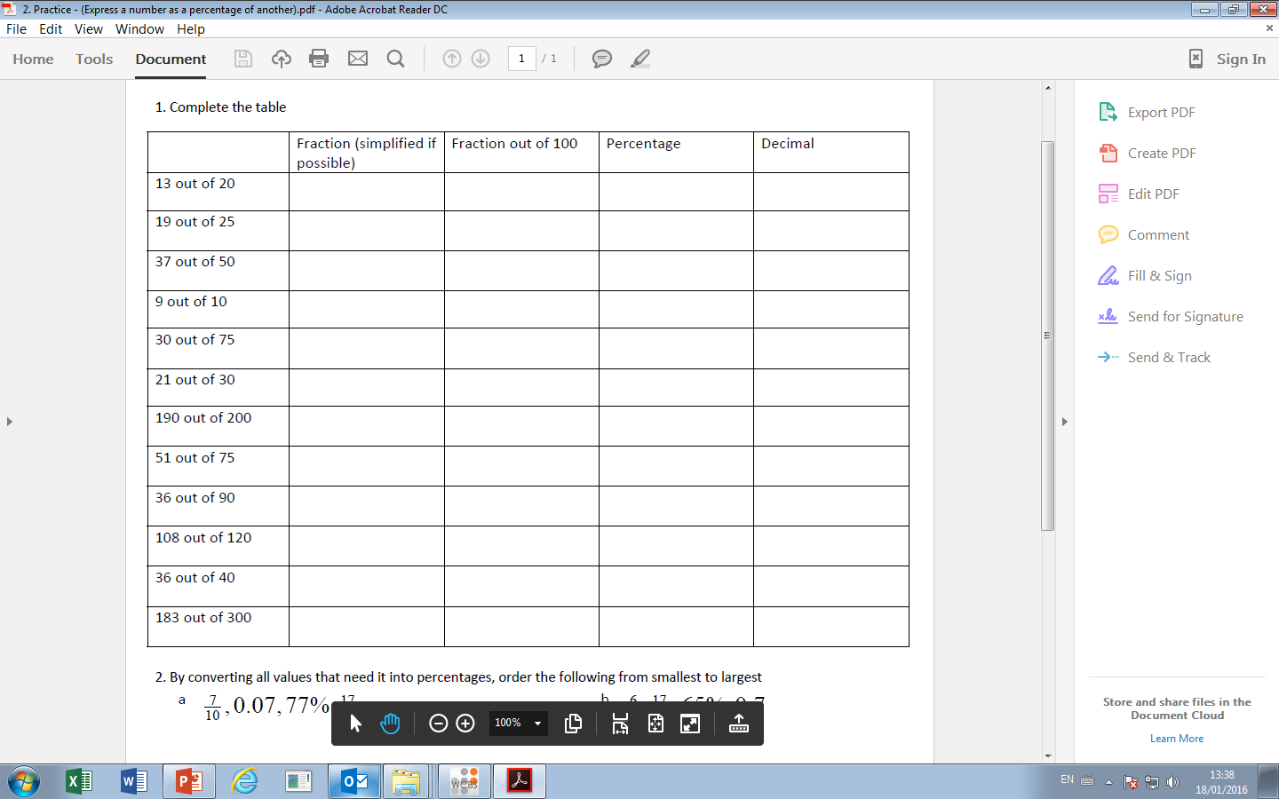
Task 2: Calculator Allowed 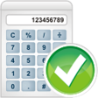

Calculate the percentage power required for each distance.
Give you answers to 1 decimal place

Club | Max Distance
Driver | 230 yards
3-wood | 210 yards
4-iron | 170 yards
9-iron | 120 yards

Distance Required (yards) | Driver  %  required | 3-wood  %  required | 4-iron  %  required | 9-iron  %  required
195
170
40
115
220

