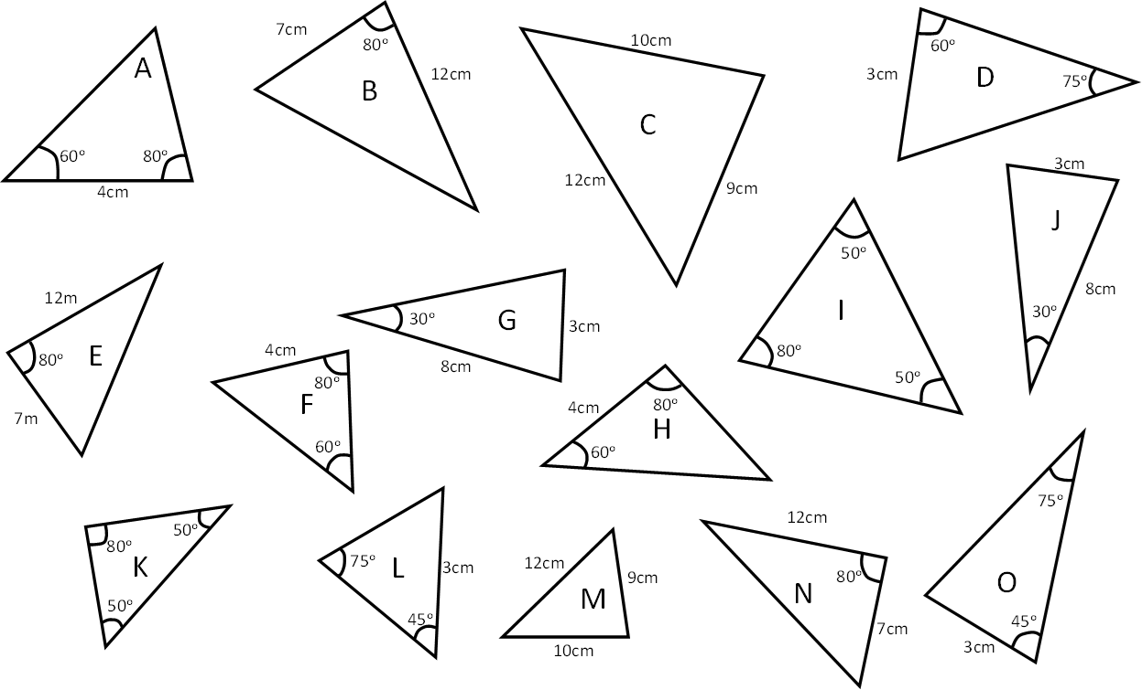
Identify the triangles which are congruent.
Place the answer under the correct reason they are congruent.
ASA

SAS

SSS

AAS

RHS
Identify the triangles which are congruent.
Place the answer under the correct reason they are congruent.
ASA

SAS

SSS

AAS

RHS

