Average – Problem Solving
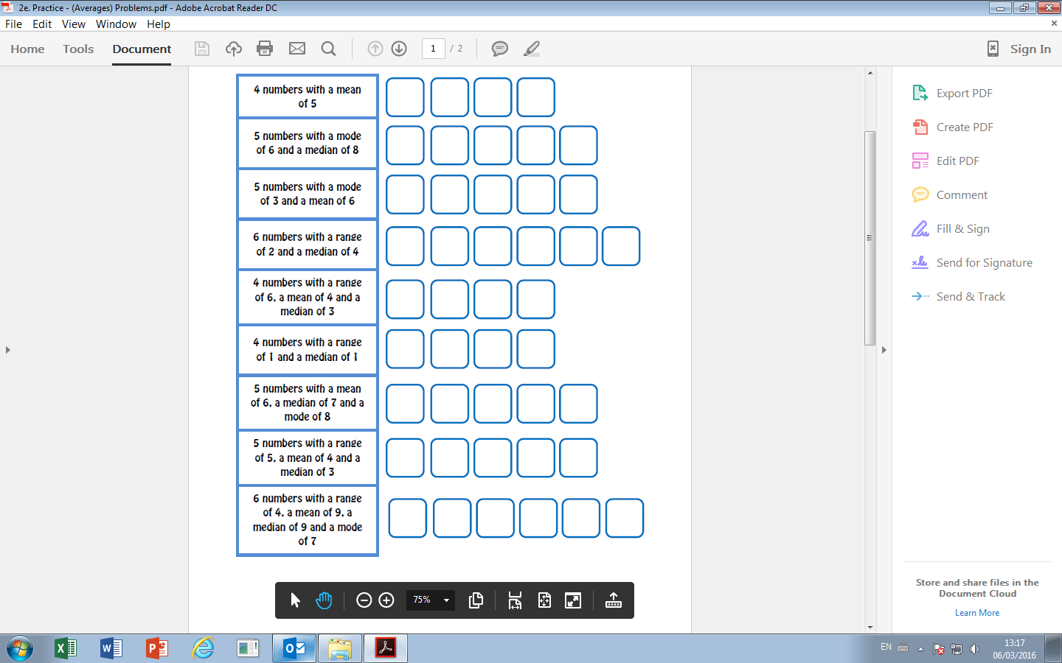
Average – Problem Solving

